Fake vs Real Job Postings Analysis in Excel
This report presents an Excel-based analysis of a dataset containing real and fake job postings. The objective of this project is to identify key patterns that differentiate fraudulent job postings from genuine ones, using data cleaning, pivot tables, and charts in Microsoft Excel.

1. Background
Online job portals are increasingly affected by fake job postings that aim to mislead candidates and extract personal or financial information. Analyzing job posting attributes such as contact details, company information, and job descriptions can help identify suspicious patterns.

2. Objective
The primary objective of this project is to analyze fake VS real job postings using Microsoft Excel. This includes cleaning the dataset, performing exploratory analysis, and generating insights that highlight common characteristics of fraudulent postings.

3. Dataset Overview
The dataset consists of 3,001 job postings with 25 columns, including job title, description, requirements, company details, contact information, and a binary indicator identifying whether a job posting is fake or real.

4. Data Cleaning & Preparation
Data cleaning was performed in Excel to ensure accuracy and consistency. Missing values were reviewed, text fields were standardized, and derived columns such as text length were used to support analysis. Suspicious indicators such as free email domains and missing company details were retained for analytical purposes.

5. Exploratory Data Analysis in Excel
Exploratory analysis was conducted using pivot tables and charts in Excel. Key comparisons were made between fake and real job postings based on factors such as telecommuting (remote or non-remote job) options and presence of company logos.

6. Key Insights
- Many fraudulent postings lack complete company information or logos.
- Telecommuting and unusually high open positions appear more frequently in fake listings.
-We performed a job-title-wise analysis using a bar graph to compare fake and real job postings.

7. Real vs Fake Job Postings Overview
The bar graph below represents the distribution of real and fake job postings in the dataset. It provides a clear comparison of the volume of legitimate versus fraudulent job listings analyzed in this project.
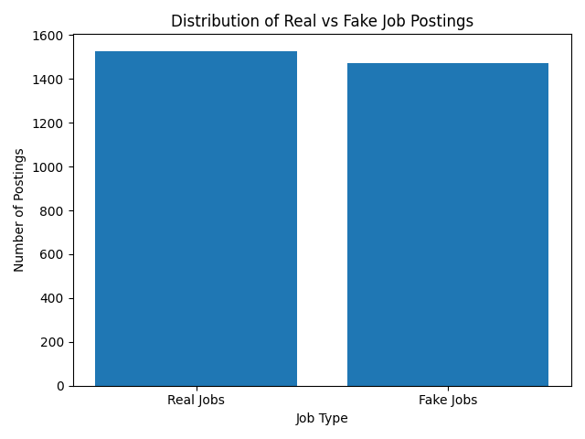
Figure 1: Bar chart showing the comparison between real and fake job postings based on the dataset.

8. Conclusion
This Excel-based analysis demonstrates that fake job postings exhibit identifiable patterns that can be detected through structured data analysis. By leveraging Excel tools such as pivot tables and charts, meaningful insights were derived without the use of advanced BI dashboards. This approach provides a strong foundation for initial fraud detection in recruitment platforms.

